CRANE Geospatial Visualization Workflow

Last Edited: 09/03/18 (created by Adam Martin, modified Olga Scrivner)

Export Authors Coordinates and Co-Authors links from Mav

Run a code to add unique ids and create nodes/edges files

[Change columns to

| **Author** | **Publications** | **Citations** | **First Year** | | **Last Year** | | **X** | **Y** | | **Latitude** | | **Longitude** |
| --- | --- | --- | --- | --- | --- | --- | --- | --- | --- | --- | --- | --- |
| **Author1** | **Author2** | **JointPublications** | | **JointCitations** | | **source** | | | **target** | |

MAX citations

**AI - 735**

**IoT - 3651**

**Rob 4357**

**After filtering:**

**AI - 735**

**IOT - 968**

**Rob - 971**

Using <https://dash.geocod.io/>

Export list of city, state for top 10 authors - <https://iu.app.box.com/folder/82311806485>

Load to gephi

Edges and nodes are exported from MAV - **make sure edges are undirected**

* Run Geolayout
* Go to filter, select Attributes, non-null > latitude > Run filter
* After filtering null nodes, copy filtered graph to a new workspace
* Delete remote nodes (islands)
* Create a node with citation # 4357 (edit node settings)
* Adjust node size to citations (4-40 min/max)
* Adjust node color by First Publication: **left dark –** 00695C,  **middle** 26A69A**, right light -** E0F2F1**,**
* Edge color - node default
* Filter edges by Joint Publication

AI: 1-13 joint pub > 2-13

Rob: 1-23 joint pubs >> 5-23

IOT: 1-20 >> 3-20

**Step 4: Appearance – Node > Color > Ranking > FirstPubYear > swipe color staring from darker to lighter > Apply**

* **TEAL palette -** <https://material.io/design/color/the-color-system.html#tools-for-picking-colors> [50-400-800] from
* **Color Reverse: - left dark –** 00695C,  **middle** 26A69A**, right light -** E0F2F1**,**

**Step 5: Appearance – Node > T label size > Ranking > TimesCited > Apply > Select T on the bottom (all labels are shown)**

Data Format:

Original data is retrieved from the Web of Science in the following format. Notice each row is a publication, and publications with multiple authors have multiple rows for each author.

|  |  |  |  |  |  |  |  |  |
| --- | --- | --- | --- | --- | --- | --- | --- | --- |
| WOS ID | # Citations | Author | Institution | Zip Code | City | State | Country | Address |
| WOS:000231234700004 | 12 | Pantic, M | Delft Univ Technol | NL-2628 CD | Delft |  | Netherlands | Delft Univ Technol, Elect Engn Math & Comp Sci Dept, NL-2628 CD Delft, Netherlands |
| WOS:000231234700004 | 12 | Grootjans, RJ |  |  | no address | |  |  |

Data Parsing:

The required output needs to be in the form of:

|  |  |  |  |  |  |
| --- | --- | --- | --- | --- | --- |
| Id | Author | Location | Latitude | Longitude | Citations |
| 4596 | Rupp, B | KK Hofkristallamt | 33.2143717 | -117.20882 | 1 |
| 10754 | Rupp, C | Univ N Carolina | 35.9722081 | -79.047556 | 12 |
| 638 | Veras, E | Univ S Florida | 27.9552692 | -82.45632 | 0 |
| 4298 | Miga, MI | Vanderbilt Univ | 36.1724885 | -86.780596 | 19 |
| 5050 | Tunay, I | Washington Univ | 38.6682669 | -90.323081 | 7 |

‘Id’ is a unique value representing the entire node. It is used in Sci2 to help create the edges between the nodes. Nodes can be ordered by each unique author or each unique location. In this case we used location.

The output for the edges needs to look like this:

|  |  |  |
| --- | --- | --- |
| source | target | Weight |
| 1814 | 1820 | 2 |
| 11483 | 11491 | 2 |
| 8851 | 8853 | 2 |
| 1507 | 1509 | 2 |

‘Source’ represents the source node ‘Id’, ‘Target’ represents the target node ‘Id’. The ‘Weight’ value is the number of connections made between those two nodes.

Link to Python code for US Parser: <https://iu.box.com/s/y1isgandoly97fiqz2uijnskyh0pkgrf>

Link to Python code for World Parser: <https://iu.box.com/s/vpxxekaaodoxy9em10t7h0rf7l59xjt8>

Geocoding is done by the Python scripts, converting country names, zipcodes, or city/states to lat-long pairs. These raw latitudes and longitudes are then used by Sci2 to generate the overlays. Sci2 performs the projections required to line-up the nodes. You may later want to add projection code to the Python scripts.

Creating the Network:

Sci2 is used to create the ‘Geospatial Network Layout with Base Map’ visualization. Before this can be done, the Node and Edge files need to be combined using the Sci2 ‘Merge Node and Edge Files’ tool. After this, the network and its base map can be generated in Sci2. Here is a step-by-step process to creating the visualization.

1. Export the generated network in GraphML format.
2. Save the base map in PostScript format, and convert to PNG in an image editor.
3. Import the GraphML network into Gephi (be sure to name your tabs to avoid mixups)
4. Perform necessary edits to the network, including:
   1. Decreasing minimum node size to decrease occlusion.
   2. Using a ‘Spline’ curve to clean-up node sizes.
   3. Applying desired color scheme and ranking to nodes and edges.
   4. Applying desired filtration to edge weights to clean up the network.
5. In the Data Library, add the top 5 most-cited institutions/countries to the ‘Labels’ column.
6. In the Preview tab, select ‘Default Straight’, and play with edge thickness until it looks reasonable.
7. You should now have a map that can be exported to SVG.

Creating the Legend:

Open up Inkscape, a free, open-source image-editing tool available online. Import the SVG network created earlier. The goal is to get something that looks like this:

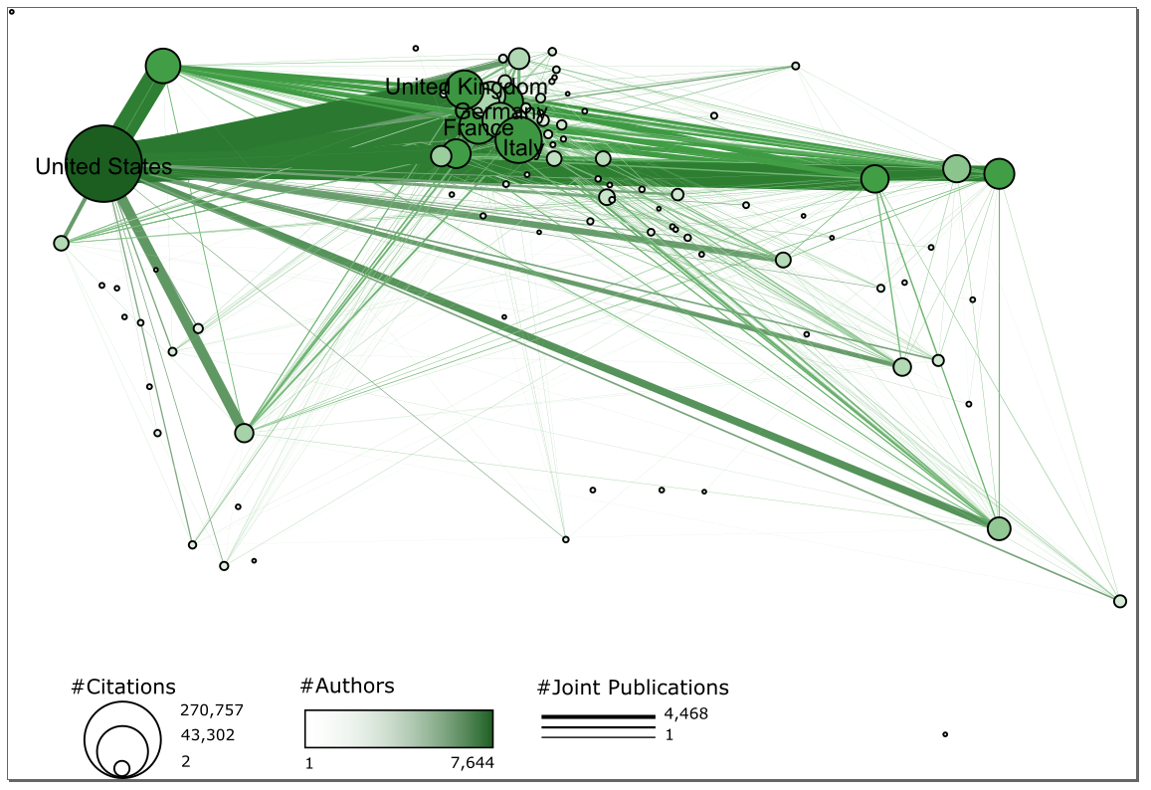

Keep in mind that you may need to cut and paste the legend in Photoshop, so its placement does not need to be perfect now. Here is the video used to create the above legend: <https://www.youtube.com/watch?v=DiKK6hcRp08>

Overlaying the Network:

Open up Photoshop and import the basemap PNG file you saved earlier, and the SVG network you just created. The goal is to align the network with the basemap using the alignment nodes, adjust the placement of the legend, and remove the alignment nodes. I achieved this using the following steps:

1. Select Edit>Transform>Scale, and rescale the network so the alignment nodes match up.
2. Use the ‘marquee select’ tool to select the legend (make sure you have the right layer selected!!)
3. Cut and paste it, and then drag it to your desired position.
4. Use the ‘Rectangle Tool’ to draw a rectangle over the alignment nodes, color this rectangle white so it covers up the nodes and blends in with the background.